SANCTUARY REPORT, MAY 2025
On May 8th, Al Jarvis and Joyce Simpson joined John Canning, Jackie Canning-Riccio, and Yvette Dudac at the 2025 Preservation Connecticut’s Awards dinner at the New Haven Country Club where they accepted an Award of Merit for the work in the First Church of Christ, Woodbridge (FCCW) Meetinghouse that was completed in December 2023. The FCCW and John Canning & Company shared the honor.
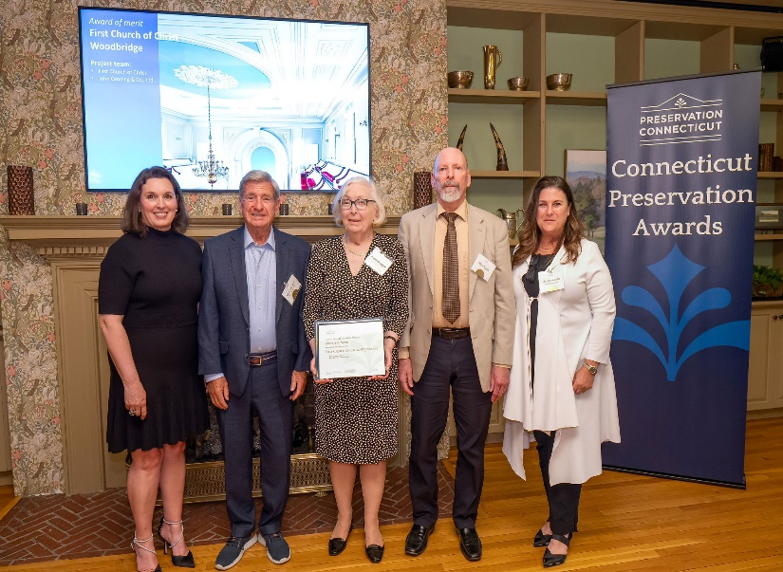
In November, 2024, John Canning & Company were awarded the prestigious Bulfinch Award by the Institute of Classical Architecture & Art (ICAA), New England, for their work at the FCCW. And on June 10th, representatives from Canning will be accepting a third honor - a national award: the 2025 Traditional Building’s Palladio Award for Craftsmanship during the Traditional Building Conference in Colonial Williamsburg, VA.. Again, both FCCW and John Canning & Company will be recognized.
As with all historic buildings, there is always something more to be done. After 20 years, the bell tower is overdue to be painted (trustees are aware). Installation of railings on the balconies and replacement of carpet and soft furnishings are ideas for the future that would be paid for by the Sanctuary Fund.
The Sanctuary Committee thank those who donated so generously to the restoration and preservation of the sanctuary, those who provided grants, and the contractors who stabilized, repaired, and gave us a “masterpiece canvas of our historical narrative.” This beautiful space is forever ours for quiet contemplation, for our worship services, as well as for future secular activities we will share with the wider community. All are welcome.
Sanctuary Committee
Photo: Ian Christmann

