The Sixth Sunday of Easter
May 5th, 2024

Prelude Nenad Ivovic

Welcome Glenn Dulko

Announcements

*Call to Worship
Leader: Come, Come into God’s loving community.
Community: We come seeking the tools, knowledge and faith to joyfully love God and share the love of Jesus.
Leader: Come, come good friends, rejoice with your hearts, souls and voice.
Community: We gather here and now rejoicing, learning and loving together, as brothers, sisters, good friends and neighbors celebrating that we are each a part of God’s Love here on earth.
Leader: We gather together now…
Community: To joyfully explore, experience and build God's love, recognize the work of the Spirit and continue the healing, helping and loving of Jesus here in our lives, this church, this community and all over the world. Amen.

Kids Church Children are welcome to join Kids Church in the Parish House Forest Vandeflor

*Gathering Hymn We Gather Together #421 Black Hymnal
We gather together to seek ask for God’s blessing.
To live in community, seeking God’s will.
We come now as sisters and brothers, confessing
The sins that divide and the wrong in us still.

Beside us, forgiving, enabling, sustaining
You call us, O savior, to life that is new
You draw us away from self centered complaining
You lead us and guides us in ways that are true

All praise to the Spirit, provider, defender.
You offer us freedom, to follow or stray,
Empowering all by the hope you engender.
Grant us wisdom and courage to follow your way

Scripture John 15 9-17 (Page 939-940 in your pew Bible)

Sermon “Love Louder“

*Hymn They Will Know We Are Christians By Our Love

We are one in the Spirit, we are one in the Lord; We are one in the Spirit, we are one in the Lord;
And we pray that all unity will one day be restored.
Chorus: And they'll know we are Christians by our love, by our love,
yes, they'll know we are Christians by our love.
We will walk with each other, we will walk hand in hand;
We will walk with each other, we will walk hand in hand;
And together we'll spread the news that God is in our land.
We Will work with each other, we will work side by side;
We will work with each other, we will work side by side;
And we'll guard each one's dignity and save each one's pride.
All praise to the Father, from whom all things come;
And all praise to Christ Jesus, His only Son.
And all praise to the Spirit who makes us one.

Service of Prayer

Joys and concerns / Prayers of the People
Pastoral Prayer and Silent Prayer
Lord’s Prayer (debts)

Offering

Call to Offering
Choir Anthem The Prayer with Lead Us, God Arr. Tom Fettke Faye Chen & Choir
*Doxology
*Prayer of Dedication

*Closing Hymn This Little Light of Mine
This little light of mine, I'm gonna let it shine; (x3)
let it shine, let it shine, let it shine.
Everywhere I go, I'm gonna let it shine; (x3)
let it shine, let it shine, let it shine.
All-throught the night I'm gonna let it shine; (x3)
let it shine, let it shine, let it shine.

Benediction

Threefold Amen

Postlude

*Please rise in body or in spirit

Upcoming Events at FCCW
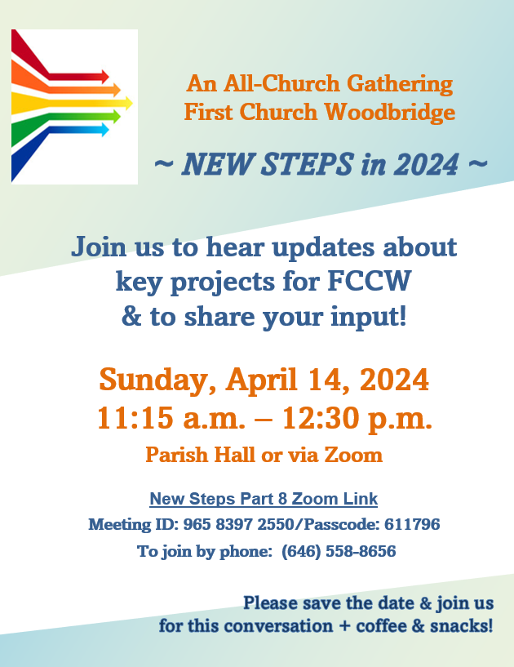

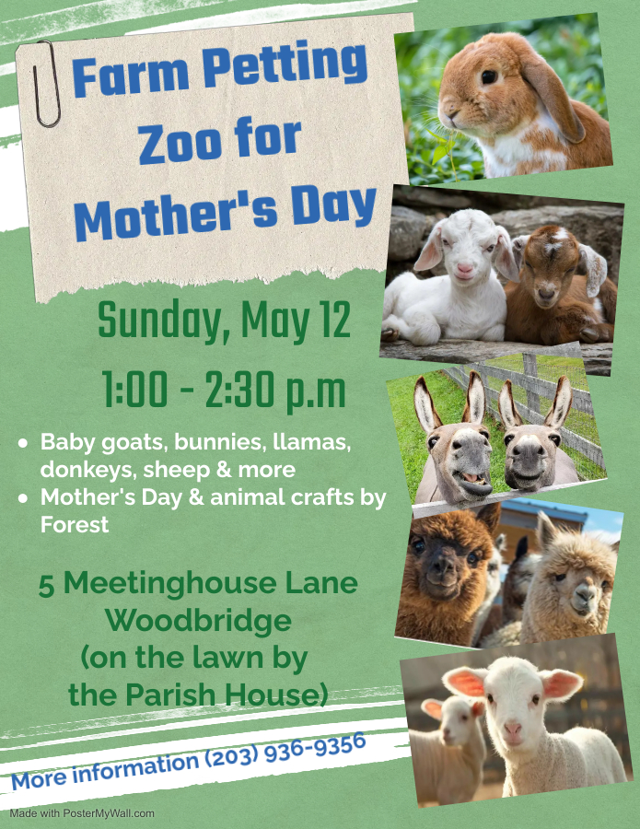
CALL TO CONGREGATIONAL MEETING
May 19, 2024, 11:15 AM

The May, 2024, Congregational Meeting of the FCCW Congregation shall be held on Sunday, May 19, 2024, at 11:15 AM in the Parish House in order to :
1. Receive a report from the FCCW Nominating Committee for the purpose of conducting an election of FCCW's Moderator, Clerk, and members of Boards and Committees
2. Receive a report from the Bylaws Committee recommending a change in FCCW's Bylaws empowering the FCCW Church Council to pass the motion allowing for Church business to be transacted from January 1st of each year until that year's Annual budgets are passed. This change also results in removing the September Congregational meeting from the Church calendar.
3. To receive and act upon any other business appropriate to come before the meeting.

Respectfully Submitted, Susan Stoddard, Clerk

Additional Copies of the proposed bylaws changes can be found in the office and the lobby of the Parish Hall

