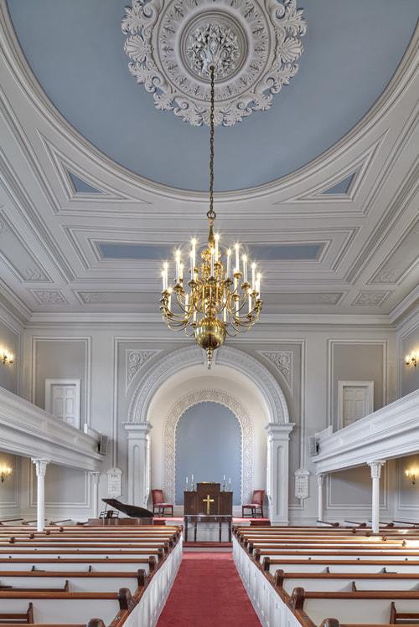
© Robert Benson Photography
FIRST CHURCH OF CHRIST
WOODBRIDGE
2024

REDEDICATION OF THE SANCTUARY

FIRST CHURCH OF CHRIST WOODBRIDGE

SUNDAY, APRIL 21, 2024

The Congregational Church in New England

In the 1600’s, early settlers seeking religious freedom established the Congregational Church in New England.
We continue to stress the freedom of individual conscience, and we are proud of our heritage that dates back to the Pilgrims and Puritans.
At the same time, we cherish our partnership with all churches affiliated with the United Church of Christ and the Church universal.
We are a diverse fellowship of individual believers from many traditions, united by our love for Christ and His mission and ministry to the wider world.
As an Open and Affirming Congregation, we welcome people from all walks of life with diverse sexual and gender identities, whom we serve through Jesus Christ.
We pledge a deep belief that God is Still Speaking, and that “there is yet still more light and truth to be revealed from the Word of God.” *

*These are the words of Rev. John Robinson to the Pilgrims departing Holland for the New World.

First Church of Christ, Woodbridge, 1738
Sanctuary Rededication Celebration, April 21, 2024
Order of Service

Prelude: “As Time goes by” by Herman Hupfeld Nenad Ivovics
Welcome: Rev. Janice Touloukian
Children leave for Kid’s Church with Ms. Forest:
Opening Hymn: “The Church’s One Foundation” Pilgrim Hymnal #260
Words of Thanksgiving from the Sanctuary Committee:
Al Jarvis and Joyce Simpson
Opening Prayer: Rev. Janice Touloukian
O Holy One, you call us to imagine a new world coming into view:
a world marked by dignity and respect, by a common resolve for
peace and justice, by an urgent desire for mutuality and love.
In this spirit, come and empower us as members and friends of your
beloved community: to practice mercy and promote peace, to work for
justice, to proclaim release from our shared captivity to fear and
misunderstanding, and to bear witness to all that our faith knows to be
possible. Amen
Choir Anthem: “Days of Elijah” with "All Hail the Power"
by Robin Mark, arrangement by Mary McDonald
Faye Chen and Choir
Trumpet: Chris Chhoeun
The congregation is invited to sing this section with the choir:
“All hail the power of Jesus' name!
Let angels prostrate fall,
Bring forth the royal diadem, and crown him Lord of all.
Bring forth the royal diadem, and crown him Lord of all.”

Old Testament Scripture: Isaiah 40: 28-31 Kathleen Foster
(page 620 in pew bible)
Gospel Reading: John 6: 25-34 Rev. Janice Touloukian
(page 928 in pew bible)
Reflection: “Architects, Builders, and Dreamers”
Pastoral Prayer:
The Lord’s Prayer:

Mr. John Canning, PA AIC, Honorary AIA: “Illusionistic Painting”

Call to Offering: Rev. Janice Touloukian
Musical Interlude: Nenad Ivovic
Doxology:
Prayer of Dedication: Rev. Janice Touloukian

Salem Covenant of 1629: Introduction by Rev. Janice Touloukian
Read in Unison: “We do bind ourselves in the presence of God to walk together in all His ways, according to how He is pleased to reveal Himself in His blessed Word of Truth.”
Closing Hymn: “Joyful, Joyful, we adore Thee” New Century Hymnal #4
Benediction: Rev. Janice Touloukian
Postlude: “Love Lifted Me” Faye Chen and Nenad Ivovic
by Howard E. Smith, arrangement by Mary McDonald
Please join us at the reception in the Parish Hall immediately following this service

SANCTUARY COMMITTEE:

Alan J. Jarvis
B. Joyce Simpson

GRANT AND FOUNDATION SUPPORT

Community Foundation for Greater New Haven
Connecticut Trust for Historic Preservation
State Historic Preservation Office and the Connecticut Department of Economic and Community Development

SANCTUARY FUND DONORS

OUR GUARDIAN ANGELS:

Paul H. and Judy DeCoster in honor of Dr. and Mrs. Clement Clarke
Nancy Dickgiesser partially in memory of Virginia Butler Calistro

OUR SERAFIM ($5,000–$20,000):

Eaton and Faye Chen
Elizabeth “Betsy” Demir partially in memory of Virginia Butler Calistro
Henry Gates partially in memory of Virginia Butler Calistro
Wilson and Carole Kimnach
William “Bill” More partially in memory of Virginia Butler Calistro
and Wilson H. Kimnach
B. Joyce Simpson partially in memory of Wison H. Kimnach

OUR CHERUBIM ($2,000-$4,999):

Jay and Barbara Baldwin
Morten and Katrena “Kit” Engstrom
Scott and Cathy Hunter
John “Jack” and Hope Jones
Patrick Madden in memory of Deborah Russell Whitlock Madden
James and Georgia Morgan
partially in memory of Virginia Butler Calistro
Penny Langeler Rogers
Susan “Sue” G. Stoddard partially in memory of Gerry Langeler
and Virginia Butler Calistro

OUR THRONES ($1,000-$1,999):

Roger Calistro and Kathleen Foster
Calvin K. Kazanjian Economics Foundation in honor of Fred Finkenauer
Dibbie Clark
FCCW Music Committee
Richard and Betty Fearon partially in memory of Virginia Butler Calistro and Wilson H. Kimnach
Martha “Muffy” K. German partially in memory of Wison H. Kimnach
Andrea Huntoon
Alan J. Jarvis partially in memory of Virginia Butler Calistro and
Wilson H. Kimnach
Carole S. Kimnach, children, and grandchildren
in memory of Wilson H. Kimnach
Carl and Annemarie Lindskog
partially in memory of Virginia Butler Calistro
Lynn Piascyk and family
in memory of her parents, aunt Audrey Grey, and
Virginia Butler Calistro
Richard and Carole Prescott
partially in memory of Virginia Butler Calistro
Annsley Slawsky in memory of Deborah Russell Whitlock Madden
George and Deb Slocum
Robert “Bob” and Janice Touloukian
Anita Wanner and David Cook in memory of Richard L. Wanner

OUR ARCHANGELS ($200-$999):

Amity & Woodbridge Historical Society in memory of Wilson H. Kimnach
Anonymous
Sally Barter
Thomas G. Black
Charlie and Karen Clark
Sarah Jane Compton and Bradley Taylor
David and Suzanne Cook in memory of Richard L. Wanner
Tim Cowles
Walter and Ethel Crosby
Jan Drummond in memory of Virginia Butler Calistro
Sharon Finkenauer
Richard and Debbie Forselius partially in memory of Gerry Langeler
Martha “Marcie” W. Freeman
David Gibson
Earl J. Glusac and Marie Robert
Krista Hart in memory of Deborah Russell Whitlock Madden
Julie Hultgren
Richard Jeynes
The Kimnach and Hains family
in memory of Rev. and Mrs. George M. Milne
Dot Larsen
Lin Li
Carl and Karen Lundborg
Ken and Lori Lynn Fast Minkema in memory of Wilson H. Kimnach
Ryan and Jackie Paxton
Steve Primus and Carmen Castro
Loch and Sandy Reidy
David and Joan Rifkin
Ira and Denise Rock
Mark and Jane Schweinhaut in memory of Virginia Butler Calistro
Stefany Schulz
John L. and Cathy Suttle

OUR ANGELS ($25-$199):

Bridget Bateson in memory of Virginia Butler Calistro
Dawn Beckert in memory of Virginia Butler Calistro
Eunice Bergmann
Skip and Gerry Borgeson
Helen Butler in memory of Virginia Butler Calistro
David Carroll in memory of Virginia Butler Calistro
Ryan Currier in memory of Virginia Butler Calistro
Joe DeCarlo
Louis DeLeone
Kay Donnelly in memory of Wilson H. Kimnach
Blaire Feeney in memory of Dawne B. Nolan
Kurt and Melinda Foster in memory of Virginia Butler Calistro
Robin Glowa
Charles and Barbara “Bobbi” Griffith
Pamela Harvey
Barbara Hayes in memory of Virginia Butler Calistro
Chris Hubbard
David Jensen
Robert and Rita Kolb
Donald and Louisa Lehane in memory of Virginia Butler Calistro
Dorothy Martino in memory of Virginia Butler Calistro
M.J. McCarthy in memory of Virginia Butler Calistro
Ellen McDonald
Judy Moore
Carolyn Nuzzi
Jo Page and Sally Sherwood
partially in memory of Virginia Butler Calistro
Ghislaine Palumbo in memory of Virginia Butler Calistro
Richard and Bonnie Quinn in memory of Wilson H. Kimnach
Judy Reynolds
Robert Rosner in memory of Deborah Russell Whitlock Madden
Corrine and Dom Schioppo in memory of Virginia Butler Calistro
Gerry Shaw in memory of Virginia Butler Calistro
Saint Andrew’s Evangelical Lutheran Church in memory of Wilson H. Kimnach
Harold and Sandra B. Stern in memory of Virginia Butler Calistro
Bettina Thiel in memory of Virginia Butler Calistro
Lili Vasileff in memory of Martha Vasileff
Mr. and Mrs. Verinis in memory of Virginia Butler Calistro
Woodbridge Republican Town Committee in memory of Virginia Butler Calistro

FIRST CHURCH MEMBERS AND CONTRACTORS
WHO STABILIZED AND REDECORATED THE CHURCH
2016-2023

John Canning & Co, Cheshire, CT
Edwin Catalan, Painting, LLC, Monroe, CT
GNCB, Consulting Engineers, PC, Old Saybrook, CT
Grand Light, Seymour, CT
Paul L. Hubbard, former B & G trustee, Bethany, CT
Kronenberger & Sons Restoration, Middletown, CT
Jeff Stauffer, Golden Nail Builders, Colebrook, CT
Sullivan Brothers, Flooring, Wolcott, CT
Robert “Bob” Turner, FCCW Custodian, Orange, CT

© Robert Benson Photography

